7. Try to authorize with the GitHub provider:

**O**

**Pull requests Issues Gist**

Authorize application

**Yii-Book by would like permission to access your account**



Review permissions

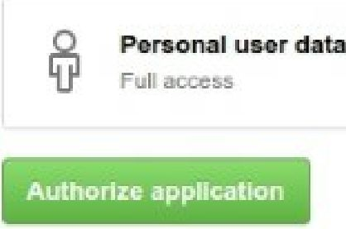

Yii-Book

N/ No description

**Visit application's website**

**© Leam more about OAuth**

8. If successful, your callback will show authorized user attributes:

[

'login' => 'Name'

'id' => 0000000

'avatar_url' =>'<https://avatars.githubusercontent.com/u/0000000?v=3'>

'gravatar_id' => ''

'url' => '<https://api.github.com/users/Name'>

'html_url' => '<https://github.com/Name'>

'name' => 'YourName'

'blog' =>site.com'

'email => mail@site.com'

]

9. Create your own authorization code in the onAuthSuccess method, like the example at [https://githnh.com/vjjsoft/vjj2-authclient/blob/master/docs/gujde/quick-stait.md](https://github.com/yiisoft/yii2-authclient/blob/master/docs/guide/quick-start.md).

How it works...

The extension provides OpenID, OAuth, and OAuth2 auth clients for your application.

The AuthChoice widget opens an authenticate page on a selected service’s site, storing the auth action URL. After authentication, the current service redirects users back while sending authentication data via a POST-request. AuthAction receives the request and calls the corresponding callback.